**Lab 2: Sensors**

1. Objectives

* To get familiar with the Arduino IDE
* To understand the function of different sensors and process the raw signals with Arduino

**Background:**

Sensors are widely used in various mechatronic systems to measure some physical properties and translate them to signals that could be understood by machines. In this lab, we will try the following two sensors and learn how to read their output by Arduino.

* 1. Digital / Analog Grayscale Sensor
  2. Ultrasonic Sensor

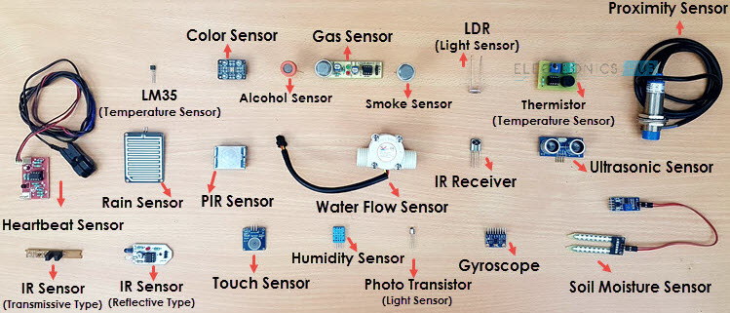

Fig. 1 – Different types of sensors

Reference: <https://www.electronicshub.org/different-types-sensors/>

**Task 1 – Digital / Analog Grayscale Sensor:**

Fig. 2 – Digital / Analog Grayscale Sensor

Grayscale sensors can recognize the color grayscale and thus be utilized as a line tracking sensor. The sensor we use for this lab has both digital and analog outputs, with operation range: 8mm – 20mm.

In digital mode, it can detect two colors (after some setup procedures) and output two voltage levels, HIGH or LOW, respectively.

In analog mode, the output value represents the detected color grayscale.

**Exercise: Distinguish WHITE and BLACK by a grayscale sensor (digital mode).**

The circuit connection is shown in Fig. 3:

Procedure:

* Connect SIG to D5 (as digital INPUT); VCC to 5V;
* Power ON and setup two colors:
  + Press the button of the grayscale sensor -> digital mode (LED not continuously varying)
  + Hold the button until LED blinks
  + Face the sensor to WHITE color
  + Press the button (confirm the HIGH output represents WHITE color)
  + LED will be OFF; Hold the button until LED blinks quickly
  + Face the sensor to BLACK color
  + Press the button (confirm the LOW output represents BLACK color)

Remark: The digital color setting would be stored even if it is powered off.

* Read the SIG (D5) pin by Arduino.
* Print out which color is detected.

**Task 2 – Ultrasonic Sensor:**

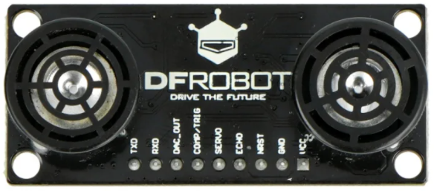

Fig. 4 – URM37 ultrasonic sensor

An ultrasonic sensor can measure the distance to an object in front of the sensor. The sensor works by sending out pulses of ultrasonic sound waves and measuring the time it takes for the pulses to reflect from the object in front and return to the sensor. Using the speed of sound in air, the time taken can be accurately converted into distance in the range of 2cm to 800cm. In this lab task, the conversion is done on the Arduino.

There are 9 pins in the module: VCC, GND, NRST, ECHO, SERVO, COMP/TRIG, DAC_OUT, RXD and TXD.

For URM37 V5.0, there are three measurement modes:

1. PWM triggered measurement mode:

* When COMP/TRIG pin is triggered by low level signal, the detected distance will be output in the form of low level pulse via PWM from ECHO pin.

1. Automatically measure mode:

* The module measures distance automatically according to the setting of time span. The detected distance will be output in the form of low level pulse via PWM from ECHO pin.

1. Serial passive measurement:

* By serial communication, you have all authority to access the sensor such as: distance measurement and temperature measurement.

In this lab, we mainly use it to measure the distance from the obstacle. Hence, we can use “PWM triggered measurement mode” of this module.

How does it work?

* Set COMP/TRIG pin to LOW
* Ultrasonic burst will be sent out through the ultrasound transmitter
* The receiver will detect the reflected ultrasonic signal by the obstacle
* ECHO pin will output the Low-level pulse as the detected distance (every 50us pulse width represent 1cm)

**Exercise: Measure the obstacle distance by ultrasonic sensor.**

The circuit connection is shown in Fig. 2:

Procedure:

* Connect TRIG to D2 (as digital OUTPUT) and ECHO to D4 (as digital INPUT).
* Use pulseIn (ECHO, value) to measure the length of ECHO pulse in microseconds.

<https://www.arduino.cc/reference/en/language/functions/advanced-io/pulsein/>

* Calculate the distance by the detected pulse width of ECHO pin:

// 50us = 1cm

* Print out the distance in Serial monitor.

***Bonus task – Indicate the obstacle distance by LED blinking:***

* The LED setup would be the same as that in LAB 1 (i.e. connect a LED to Arduino D3 pin)
* Obstacle moves closer -> LED blinks faster

Remarks: LED starts blinking if there is an obstacle within 30cm